**DATA CLEANING AND FINDING THE IMPORTANT COLUMNS**

We GOT ACCURACY OF 87% USING Random FOREST ALGORITHM.

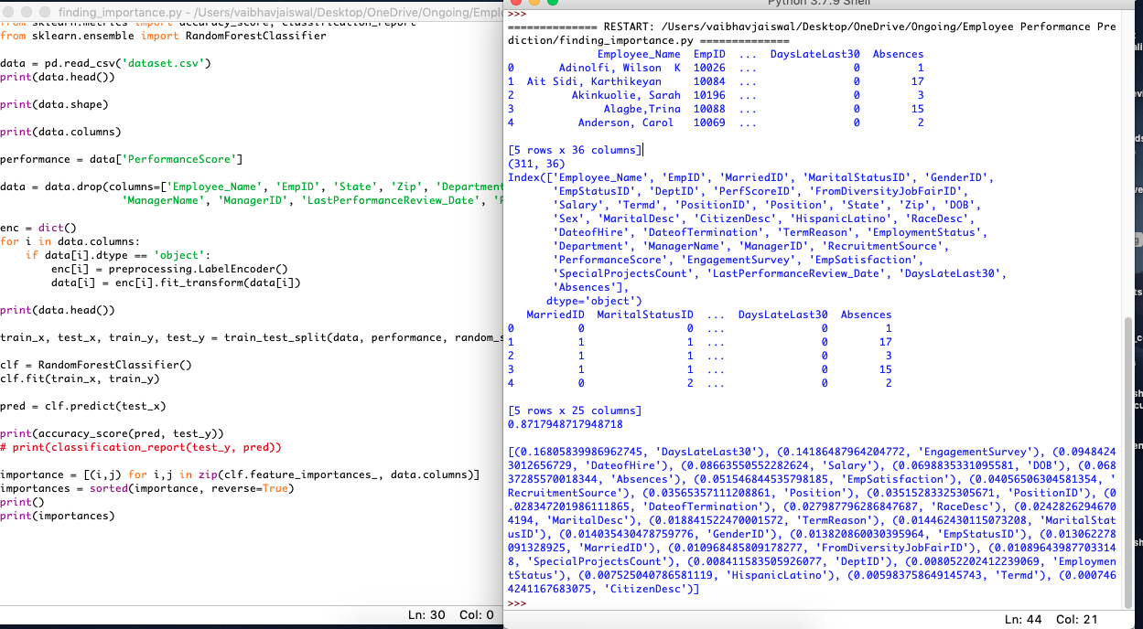

**USING THE IMPORTANT COLUMNS TO TRAIN A MODEL FOR FINAL USE**

This Model will be used for final output. As we are asking User Input So that project can work in real-time, we limited the number of inputs to 7.

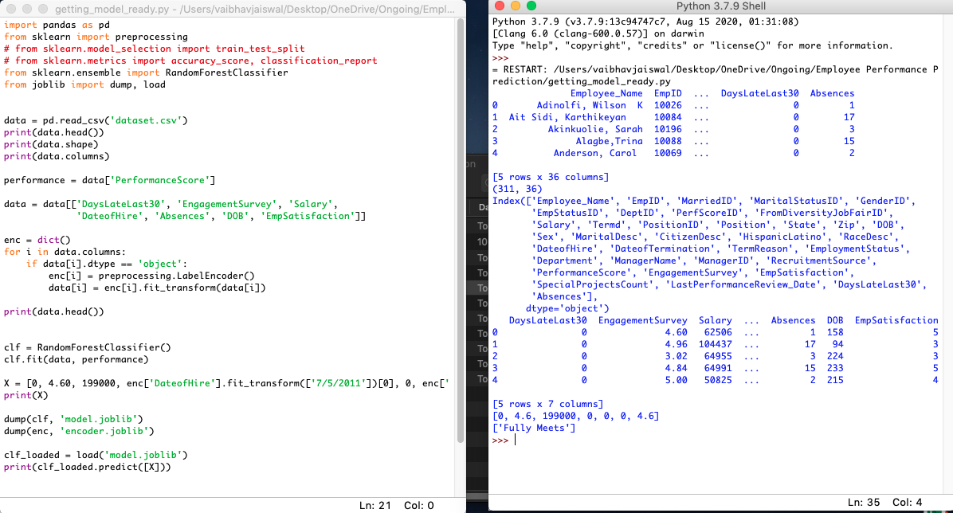

**FINAL OUTPUTS**

